Lab 3: Heart-rate Monitor Report

TRC3500 Sensors and Artificial Perception

## Lab members

|  |  |
| --- | --- |
| Kun Zhang | 22701478 |
| Seow Sheng Lun | 22724281 |
| Jiapeng Zhou | 24531308 |

# 1. Introduction

In this lab, a heart-rate monitor has been constructed. The heart rate of the subject is measured by pressing his fingertip on a sensor that measures the change in skin reflectance as the arteries near the fingertip vibrate. The sensed signal is then passed through a signal processing circuit that amplifies the input into 5V logic pulses. The pulses trigger the blinking of an LED, which is synchronised with the subject’s heartbeat.

# 2. Equipment and Components

Equipment used in this lab:

* Oscilloscope
* Multimeter
* Hook-up wires
* Prototyping plug board
* Soldering iron

Components used in the circuitry design:

* LM324 quad operational amplifier
* Red LED (High brightness)
* CdS photocell
* Plastic block to hold the LED and photocell
* A green LEDG-clamp
* Resistors (Ω): 1k, 47k
* Electrolytic capacitors (F): 2.2 $μ$, 4.7 $μ$
* 74HC14 Hex Schmitt invertor

# 3. Theoretical Background

A non-invasive heart rate monitor is imperative to monitor the health of a patient. One of the ways to implement this is to measure the variation in skin reflectance when the arteries near the fingertip vibrate. It is suggested that the change in reflectance is of the order of 1%.

A high brightness red LED is used as a light source. The skin will be illuminated by the red light and reflection from the light will be detected by cadmium sulphide cell. A cadmium sulphide (CdS) cell is an inexpensive photoresistor. Upon increasing intensity of light, the resistance of photoresistor decreases. It is suggested that the resistance of the photoresistor can be as high as a few mega-ohms in the dark. While in the light, its resistance decreases to few hundreds ohms. Therefore, its sensitive nature enables it to sense the vibration through the skin at fingertips, which is caused by the vibration of the arteries. Also because of its high sensitivity, the light sensing circuit is highly susceptible by interference from the room illumination. A solution to that is to block the CdS cell with one’s finger so that it is almost completely blocked from the lights in the room. In addition, a Schmitt trigger is preferred as it does not respond to change of state as fast as a comparator. That is to say that hysteresis of a Schmitt trigger allows it to reject certain undesirable glitches or noises. The specification of the LED suggests a 5V is appropriate to illuminate the LED. As a consequence, amplification is required.

# 4. Procedures

1. Firstly, we fixed the high brightness LED and CdS photocell on a plastic block side by side. The output pins were soldered to wires so that they could be connected to the breadboard.

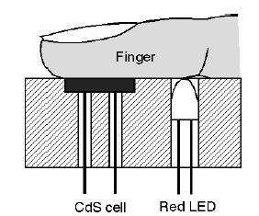

Figure 1 Sensing head (from Lab Manual)

1. The frequency of the heart rate for an adult human is around 60 – 80 beats per minute according to Robert Berne [1]. Hence, the target frequency is around 1 – 1.33 Hz. The low pass filter was then designed according to this frequency.
2. The outputs from the filters were read on the oscilloscope and the gain for the amplification stage was calculated.
3. A Schmitt trigger had been used after the amplification stage which intensifies the output signals.
4. The green LED was connected to the final output terminal that lights up in-sync with the measured heart beat pulse.
5. The final outputs were also read on the oscilloscope and recorded.

# 5. Circuit built

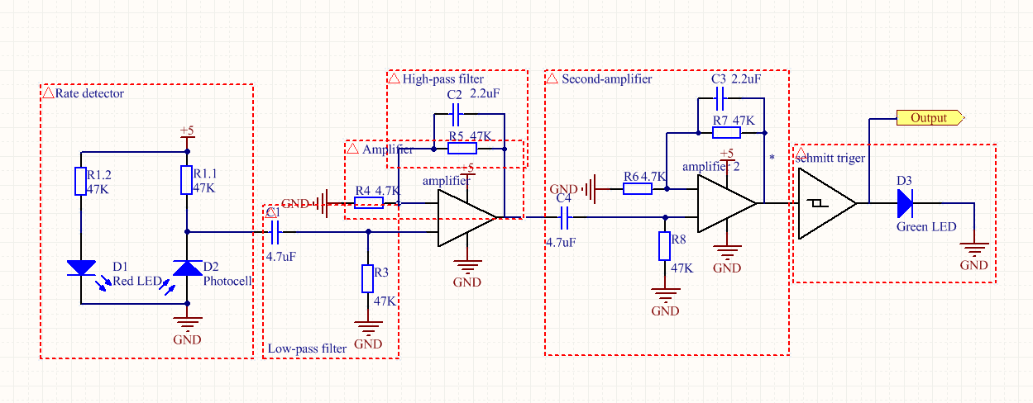

Figure 2 Schematic of heart rate monitor detector

For the circuit design we separated it into six parts, heart beat rate detector, two active low-pass filter amplifiers, high-pass filters and a Schmitt trigger.

## 5.1 Heart Rate detector

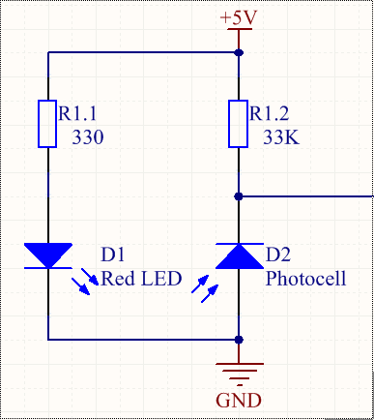

Figure 3 Rate detector circuit schematic

In this circuit, we use a red LED and a photocell to construct the heart rate detector. We do not want the current through the LED to become so high, so we used a 330 Ohms resistor to control the current flowing into the LED. When the ambience light around photocell changes, the resistance for the photocell changes too. When there is constant light shinning into the photocell, the resistance for the photocell was around 10 kOhms. We added one 33kOhms resistance along the photocell, so when the resistance drop in photocell, the voltage drop observe from the photocell would be significant.

## 5.2 High-pass filter

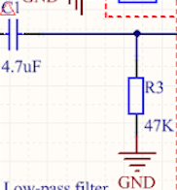

Figure 4 High pass filter circuit

The voltage change for the photocell is around several mV and it has an offset about 200mV. A high pass filter was added to block the DC offset at every amplifier before amplifying the signal. An adult human beat rate is about 1-1.33 Hz. So the high pass filter is designed to pass the signals, which has a cut off frequency higher than 1 Hz. The governing equation is given by

$f=\frac{1}{2πRC}$ (Equation 1)

Capacitor and resistor of 4.7uF and 47kOhms were chosen in this lab. Thus, the cut-off frequency for the filter using equation 1 is found to be:

$$f=\frac{1}{2×3.14×47×{10}^{-6}×4.7×{10}^{3}}=0.72HZ$$

Therefore, all signals with frequency higher than 0.72Hz are allowed to pass through the filter.

## 5.3 Low pass filter

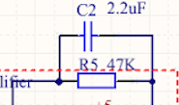

Figure 5 Low pass filter circuit

Signals after the high pass filter contained huge noise. Hence an active low pass filter was implemented to block the noise. Because the human beat rate is about 1-1.33 Hz, the low pass filter must pass signals whose frequency is lower than 1.3Hz.

Capacitor and resistor of 2.2 uF and 47 kOhms were selected in the lab. Using the similar method, we can found that the actual cut-off frequency is given by

$$f=\frac{1}{2×3.14×47×{10}^{-6}×2.2×{10}^{3}}=1.54HZ$$

As a result, all signals that have frequency lower than 1.54Hz can pass through the filter.

## 5.4 Two amplifiers

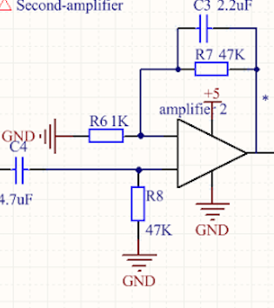

Figure 6 Amplifier circuit

The Schmitt trigger can only be operated with an input voltage range of 1 - 4V. As we know, the voltage change from the photocell is only several millivolts. So we need to amplify the voltage from the order of millivolts to that of volts. In order to achieve that, we used two differential amplifiers that both have a gain of 47. At the end, the amplification from both amplifiers gave out a total voltage gain of 2209, which would amplify the signal tremendously. Two amplifiers were used instead of just one due to high output impedance, which could cause loading effect to the amplifier. With two amplifiers, low output impedance from the amplifier was achieved.

## 5.5 Schmitt trigger

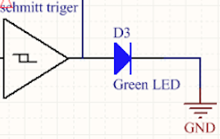

Figure 7 Schmitt trigger circuit

We would like the output voltage to be held at 5 volts so that it could light up the green LED in-sync with the heart beat pulse. In this case, we chose to use Schmitt trigger to hold the output voltage. The hysteresis property of the Schmitt trigger function as such that when the voltage increases to 4 V or higher, the output voltage from the Schmitt trigger clipped at 5V, and dropped back to 0V when output voltage was lower than 1V. Therefore, the green LED would light up when output voltage is high and dim when it is low, synchronising with the measured heart beat pulses.

# 6. Oscilloscope’s figures analysis

In this lab, we use oscilloscope to validate if the output signals for each part meet our expectation.

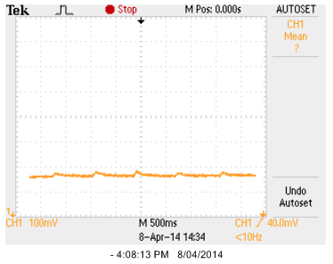

Figure 8 Output waveform with offset

From the figure 8 shown above, we can observe that the offset for the signal is more than 100 millivolts but the voltage change is only about several millivolts. Therefore, we need to use a high pass filter to filter out the offset.

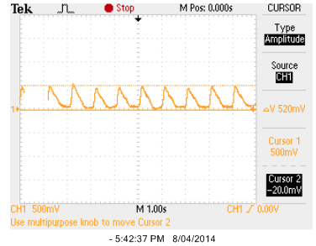

Figure 9 Output waveform after first amplify

From the figure 9 shown above, we can find that the signal after the first amplification have an output of 520mV. The Schmitt trigger operating voltage is around 1-4V, so we need a second amplifier to amplify the signal to several volts.

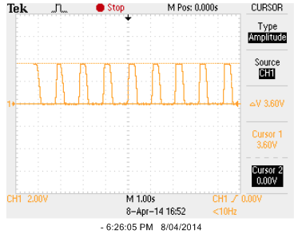

Figure 10 Output waveform after second amplifier

From the figure shown above, we can notice the output signal has already been amplified to 3.6V. Hence, we can now output the signal to the Schmitt trigger to acquire digital outputs as shown in Figure 11.

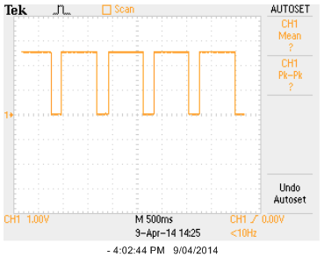

Figure 11 Output waveform after Schmitt trigger

# 7. Error analysis

The expected output voltage from the second amplifier was around 5V, but from both the output waveforms of second amplifier and Schmitt trigger, we found that the maximum output voltage was around 3.6V. The voltage supplied to Schmitt trigger and the two amplifiers was 5V, due to the fact that most amplifiers cannot drive their output to the supply rails, which in this case 5V.

The output was noticed to be noisy in occasions, which might arise from conductive coupling where pulse of current was drawn from the supply. In order to minimise this effect, decoupling capacitors were added across every power supply connections.

# 8. Future development

For further development, we can add an A/D converter, which change the analogue signal to the digital signal and feed into a microcontroller for further process. Besides, we can design a wireless transmission between the heart rate monitor and a PC, so that a heart beat rate can be monitored while human is exercising.

# 9 Conclusions

A heart rate monitor has been designed, constructed and tested in this lab practice. The heart rate monitor is able to reflect the heart rate of test subjects. Although the accuracy of such approach is not considerably high, it provides a low-cost solution for heart rate measurement.

# Reference

|  |  |
| --- | --- |
| [1] | R. Berne and M. Levy, Physiology, Elsevier Mosby, 2004. |